



SATS – Moving Azure Resources Between Resource Groups

Please direct all Enquiries with Respect to this Document to:
- Coforge SS-Cloud_APAC
Level | Name | Contact No | Email
L1 | SS-Cloud_APAC Team | 9711880047 | SS-Cloud_APAC@coforge.com
L2 | Saroj Kumar Gupta (Infra) | 7407894320 | sarojkumar.gupta@coforge.com
L2 | Prabal Mishra (OS Team) | 8826108233 | Prabal.mishra@coforge.com
L3 | Bhupendra Sharma | 9871144731 | bhupendra.1.sharma@coforge.com
L4 | Mayank Kumar Mishra | 9999673041 | mayank.mishra@coforge.com
L5 | Puneet Chopra | 9560644554 | puneet.chopra@coforge.com

- SATS
Level | Name | Email ID | Contact Number
Level 1 | Ajaya Kumar Sabata | Ajaya.Sabata@coforge.com | 7483978967
Level 2 | Madan Kumar | Madan.kumar@coforge.com | 9845292755
Level 3 | Pankaj Jain | Pankaj.Jain@coforge.com | +65 9299 6669
Level 4 | Abhishek Avinash Sehgal | Abhishek.Sehgal@coforge.COM | 6591187384

Document Control
Version | Date | Author | Reviewer | Revision Requests | Approving Authority
1.0 | 27-10-2025 | Ashutosh Padhi | Shubham Sharma | Initial Version

Table of Contents
1. Purpose 4
2. Scope 4
3. Audience 4
4. Prerequisites 4
5. Pre-Move Validation 4
6. Steps for Moving the resources 4

Purpose
To outline the standardized procedure for safely and efficiently moving Azure resources from one Resource Group (RG) to another within the same subscription.

Scope
This Standard Operating Procedure (SOP) applies to all Azure resources that support movement between Resource Groups within the same subscription under the same Azure Active Directory (AAD) tenant.

Audience
The intended audience of this document are COFORGE SS-Cloud Team and the staff of SATS involved in ITSM.

Prerequisites
- Access to the Azure Portal.
- Appropriate RBAC permissions (Owner/Contributor) on both source and target RGs.
- Resources must support moving operations.
- No active locks on source or destination RGs.

Pre-Move Validation
- Identify resources to move and dependencies.
- Validate move capability in Azure Portal.
- Check downtime requirements.
- Take backups/snapshots.

Steps for Moving the resources

Step 1: Go to Azure Portal and search for Resource Group Manager.

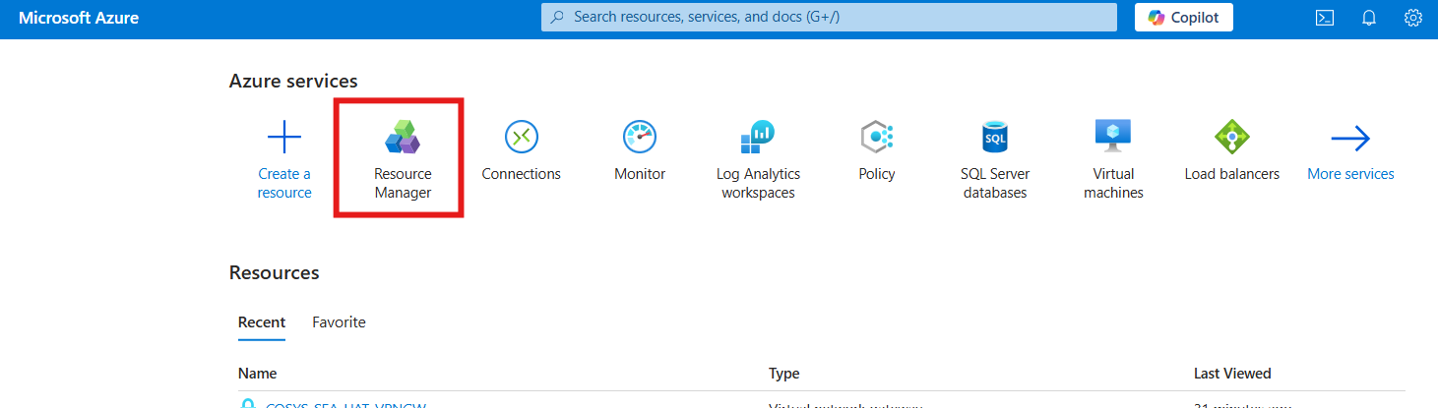

Step 2: Then, Go to Resource Groups and select the Resource Group.

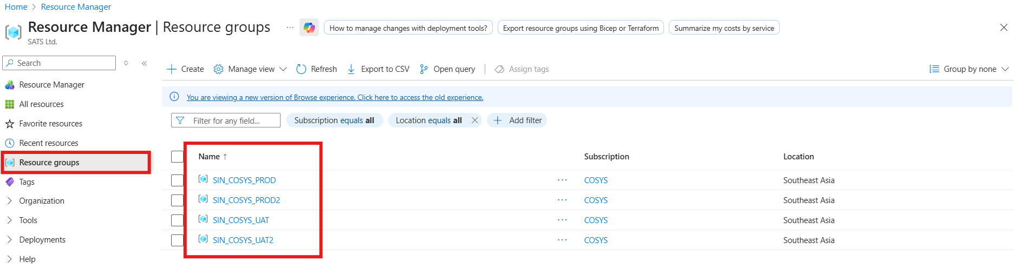

Step 3: Now, check all resources to be moved.

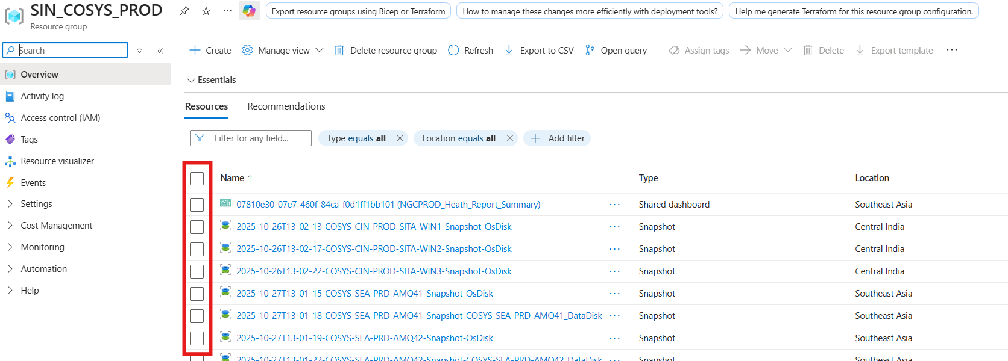
Step 4: Click Move → Move to another resource group.

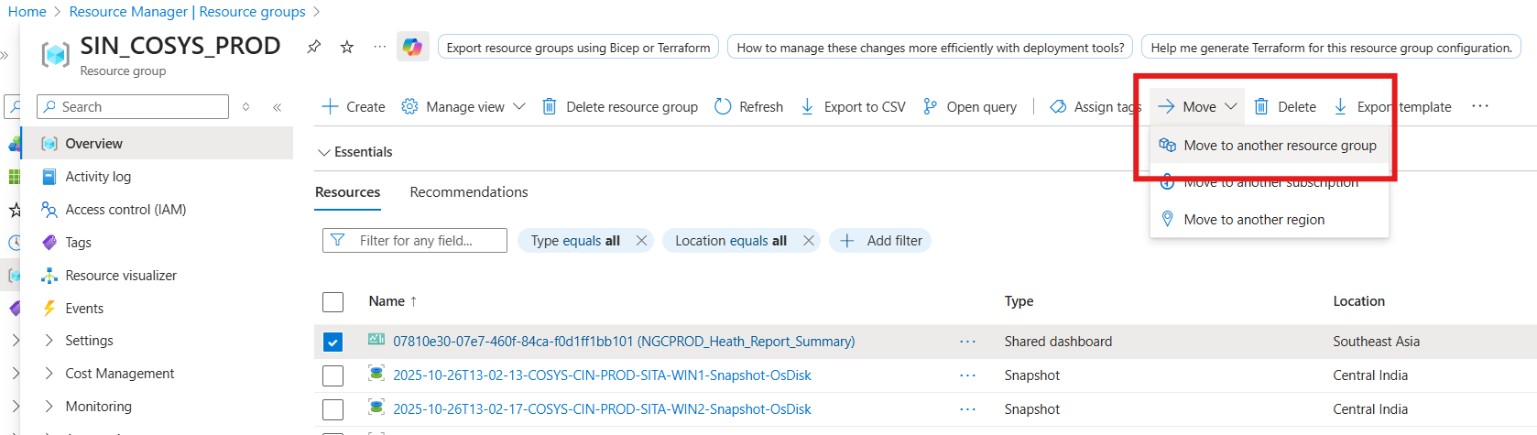

Step 5: Select the target resource group and click on Validate.

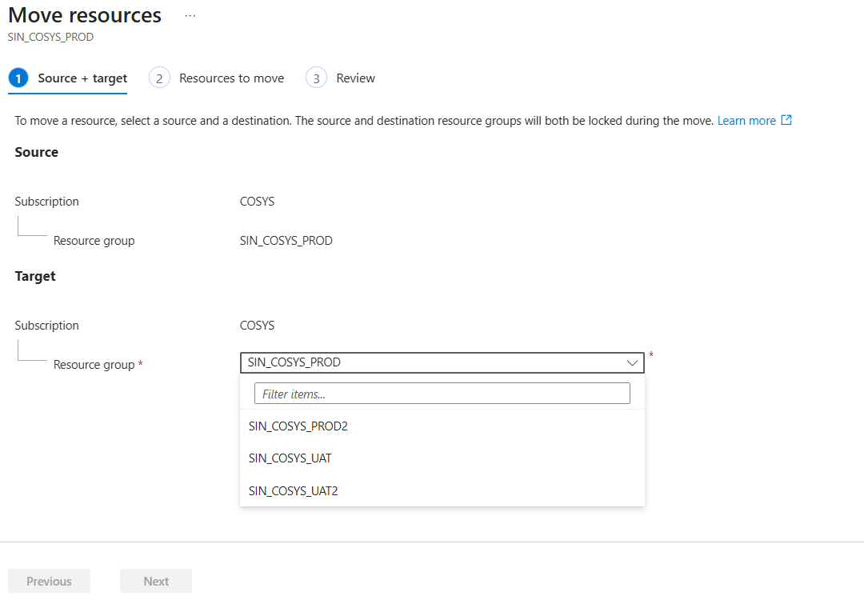

Step 6: Post the validation check, check the checkbox below and click on Move.

